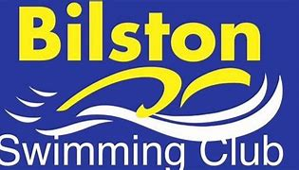

Welcome to
Bilston Swimming Club
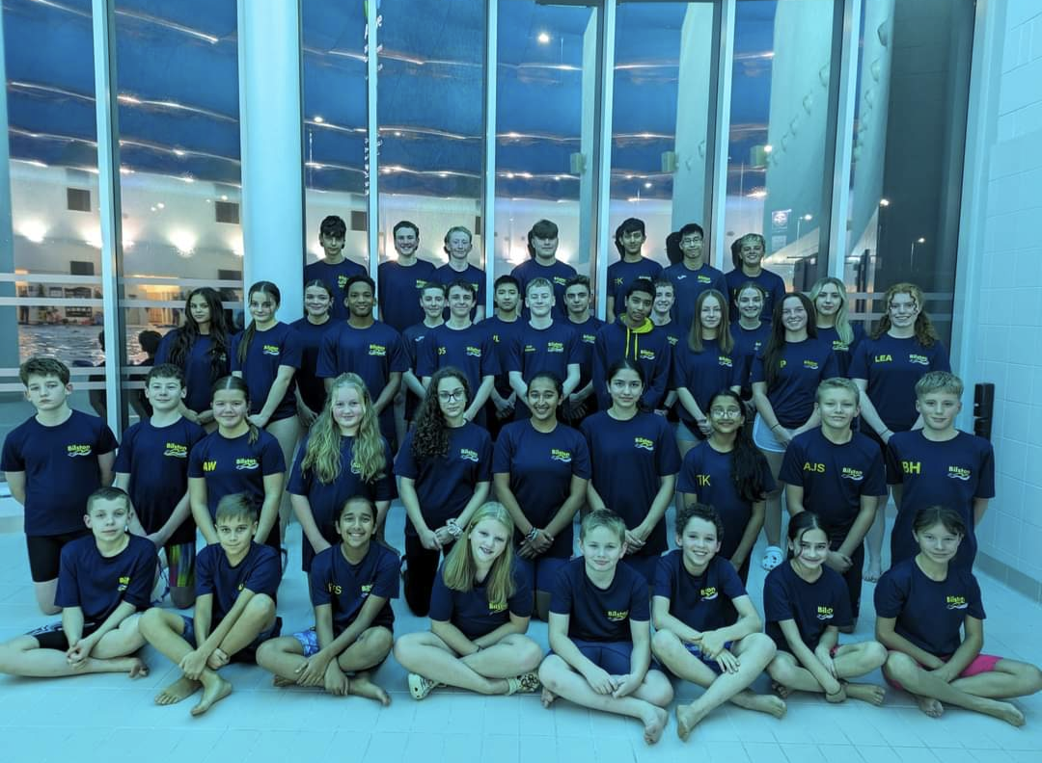

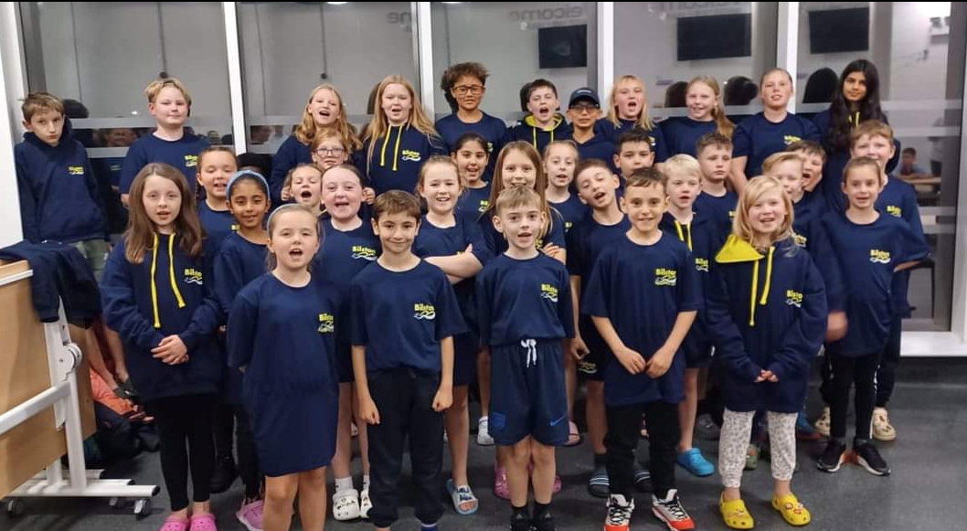

INFORMATION BOOKLET

WELCOME

Welcome to Bilston Swimming Club.

We are pleased you and your child have chosen to swim at the club and hope you have an enjoyable and happy time here as a swimmer and a family.

This booklet is designed to give you all the key information you need to know about our club and how to join with relevant contact information.

Please explore the Clubs website www.bilstonsc.co.uk which provides lots of useful information. Please also remember to look at the notice board, Social Media pages and your emails. For any other queries, please speak to our parent liaison/coaches.

Bilston Swimming Club is affiliated to the Staffordshire County in the West Midland Region of Swim England. All potential new members are entitled to 2 free trials before deciding if they would like to join us. Trial dates/times can be arranged by contacting: Kimdean.bilstonsc@gmail.com or Marierusson.bilstonsc@gmail.com.

We cater for children of all abilities from learn to swim to national performance level. After your free trial session, one of our coaching or teaching staff will speak to you and advise you which squad your child would be best suited to.

www.bilstonsc.co.uk

Joining and Membership Fees
Upon joining the club, a £25.00 membership fee is payable via Go Cardless. This is facilitated by the company GoCardless and the link will be sent to you by the membership team. Your monthly fees will then be set up depending on the squad you join and include insurance fees for the year. We do not accept cash payments for membership and monthly fees.

ASA Categories – Swim England Annual payments are due every January or upon joining (one payment per year) will be collected by membership team via GoCardless.

Your child will fall into one of the below categories: (Fees may vary each year)

Club Train membership: £20.35 (Age 7-8)
This is for individuals who are part of a club and are learning to swim or are swimming at any level within the club network. It is not for people who compete in open competition in any sport, unless the event has an exemption under Swim England Law or is designated as Low Level Competition.

Club Compete membership £42.70 (Age 9+)
Club Compete is our biggest category as it is for people who want to compete and be part of a structured competitive pathway. It is for your club members who want to compete in competitions not exempted under Swim England law, or designated as Low Level Competition.

Club Support membership £10.00
Club Support is for anyone involved in a club who isn’t covered by Club Train or Club Compete, such as volunteers, coaches and teachers.

Please note: Our Membership team will liaise with you to arrange your membership, payments, annual fees & any other GoCardless payments required.

Please see membership policy via our website
www.bilstonsc.co.uk

Please contact our Membership team for any queries: Membership.bilstonsc@gmail.com

Club Monthly Fees

Fees are stage-related and are payable by Go Cardless -monthly. The coaches will decide on the squad your child will join.

If a family has two swimmers they are entitled to a family discount. (if paying full maximum membership- excludes reduced session plans) Discount of £7 per month (from family total) if two swimmers. – Please liaise with Membership for clarification
Junior Development  X2 Sessions a week  (expectation to swim-twice weekly)  *excluded from family discount | £40.00
Junior Development  X3-5 Sessions a week  (expectation to swim x3 mini a week) | £55.00
Performance 1  (Minimum 3 sessions a week) | £59.00
Performance 2  (Minimum 4 sessions a week) | £70.00
Performance 3  (Minimum 4/5 sessions a week) | £70.00
College/Exam Plan – Senior Swimmers in Year 11 or above:  To be discussed/agreed with Head coach (parents to liaise with Kim)  (x3 max sessions a week)  (x2 max sessions a week)  *excluded from family discount | £50.00  £40.00

Please note: Anyone joining performance will receive updates regarding criteria required.

Our home pool is the Bert Williams Leisure Centre, but we also use Darlaston Leisure Centre, Wednesbury Leisure Centre and a school pool (Willenhall E-Act Academy) for some of our sessions.

 | OUR TRAINING LOCATIONS
 | Bert Williams Leisure  Centre  Nettlefolds Way  Bilston  WV14 0EF | Willenhall E-Act Academy  Furzebank Way  Willenhall  West Midlands  WV12 4BD  West Walsall E-Act Academy  Primley Avenue  Walsall  WS2 9UA | Darlaston Leisure  Centre  Victoria Road  Darlaston  WS10 8AP | Wednesbury  Leisure Centre  High Bullen  Wednesbury  WS10 7HP

Our TEAM

HEAD COACH
Kim Dean

Email: kimdean.bilstonsc@gmail.com
Contact number will be provided upon joining

Lead Development Coach
Marie Russon

Email: marierusson.bilstonsc@gmail.com
Contact number will be provided upon joining

Performance Coaches
Haley Millard & David Gallagher

Development Coaches
Josh Lockley / Luke Molloy / Megan Dean
Development/Performance Support
Teachers/Coaches & Teaching Volunteers

Neal Daly | Logan Hyde
Luke Trout | Heidi Dean
Lily-Ann Dean | George Darling
Jake Daly | Millie Cotton
Jane Ambrose | Maija Putane
Debbie Arnot | Emma Hindle

Committee

Our club is run by a committee and these volunteers meet monthly.

Executive committee members are as follows:

Chairman: Russ Powers chairperson.billstonsc@gmail.com

Vice Chairman: Leanne Spencer

Treasurer: John Millard

Secretary: TBC

There are many volunteering opportunities throughout the club ranging from officiating at competitions, team managing, fundraising etc. So, if you want to get involved, Please just ask!

Communication

Please email your child coach directly if you have any concerns.
Performance – Kim Dean kimdean@nhs.net
Development – Marie Russon marierusson.bilstonsc@gmail.com

Competition Secretary: Claire Cotton: secretary.bilstonsc@gmail.com

Club Competitions
As a competitive swimming club, we compete in a range of competitions throughout the year. These include open meet competitions at weekends, county and regional championships and league Saturday evening galas.
We have teams in the following league competitions each year. Each has slightly different age categories (age at end of year as defined by specific competition rules)
JUNIOR “Diddy” Swimming League - Ages 9,10,11,12
National Arena Swimming League - Ages 11,13,15, Open
STAFFORDSHIRE Swimming League - Ages 9, 11,13,15, Open
MERCIAN Swimming League - Ages 10,12,14, Open
All team selections are made by the Head coach/Lead coaching staff – Swimmers are contacts for availability and often posted on the club noticeboard.

OPEN Meets
We regularly offer swimming competition opportunities to our swimmers from Age 9+, we highly recommend all swimmers participate in these events. Your coach will send relevant information to you throughout the year.
- For any open meet queries- please contact our competition secretary:
Competition Secretary: Claire Cotton: secretary.bilstonsc@gmail.com

Equipment required for training

- Well-fitting goggles (& spare goggles)
- BILSTON SC drinks bottles ONLY- (filled with water/Squash-No fizzy)
- Swimming costume or swim trunks (no beach type shorts)
- Swimming hats for long hair (Pack spare hats)
- Mesh kit bag requirements:
Development require: Kick board, Pull buoy and Fins
Performance require: Kick board, Pull buoy, Snorkel, Hand paddles and Fins

Club Kit

Club kit including hoodies, hats and T-Shirts can be ordered via our club shop on Tuesdays/Fridays. - Please see Russ/Sam Powers
- Available form Bert Williams Tuesday & Fridays.

A Guide to competitions – can be located via the Club Website;
(under: Club information – Beginners Gala Guide)
Bilston SC - Guide to competitions

CLUB STRUCTURE

MINI CLUB (LEARN TO SWIM) → 4 years +
Our swim-school CURRENTLY runs on Sunday afternoons and Monday evenings at Darlaston Pool. Payments are now collected via Go Cardless (via mini club membership team)
Email: foundationstage.bsc@gmail.com
Contact Number: 07710 184837
Website: https://www.bilstonsc.co.uk/StaticPage.aspx?idPage=6

DEVELOPMENT: usual age range 7–12 years old

This section of the club is for those who are beginning and developing their interest in swimming and starting take part in competitions. Swimmers in this squad can swim up to 5 times per week. The aim is to develop all 4 strokes, to teach proficient diving, to learn competitive turns and take part in competitions. Some swimmers in this section will be expected to gain County qualifying times.

It is recommended that swimmers train at least 3 times per week but there is an option to train 2 times per week. (to be discussed with Lead Development coach)

Training Times

DEVELOPMENT SQUAD SESSIONS
DAY | TIME | WHERE
Monday | 2000 - 2100 | Bilston
Tuesday | 1900 –1945 or 1945 - 2100 | Bilston
Thursday | TBC | TBC- see Marie
Friday | 1900 - 1945 or 1945 - 2100 | Bilston
Sunday | 1530-1700 | Darlaston

PERFORMANCE

The performance squads are for swimmers who are committed to competitive swimming and are felt to have long term potential. They will be aiming to qualify for county and regional competitions as they progress through the squads.

Please note that movement from the development to performance squad is at the discretion of the Head coach/Lead Development coach.

Swimmers must train a minimum of three times per week in P1 and a minimum of four times per week in P2 & P3. As swimmers move through P2 into P3 they will be aiming for further county & regional qualification and set their sights on qualifying for Summer British and English Nationals.

Swimmers who require to reduce sessions temporarily due to GCSE’s/A-Levels etc – This will need to be discussed/agreed with Head coach prior to commencing a reduced training plan.

Training Times

 | DAY | P1 | P2 | P3
 | MONDAY | 1900 – 2030 @ DARLASTON | 1900 – 2100 @DARLASTON | 1900 – 2100 @ DARLASTON
 | TUESDAY | ----- | 1900 – 2100 @ BILSTON | 1900 – 2100 @ BILSTON
 | WEDNESDAY | 2000 – 2100 @ WEDNESBURY | 2000 – 2100 @ WEDNESBURY | 2000 – 2100 @ WEDNESBURY
 | THURSDAY | 1915 – 2100 @WEDNESBURY | 1915 – 2100 @WEDNESBURY | 1915 – 2100 @WEDNESBURY
 | FRIDAY | 1900 – 2100 @ BILSTON | 1900 – 2100 @ BILSTON | 1900 – 2100 @ BILSTON
 | SUNDAY | 1500 – 1700 @ BILSTON | 1500 – 1700 @ BILSTON | 1500 – 1700 @ BILSTON

Club Noticeboard
Please regularly check our club’s notice board at the Bert Williams Leisure Centre every time you swim for any new information/updates etc. Team selections for galas can be posted on this board.

Team/Gala Selections:
Coaches will contact parents for availability (or) display team sheets on our club noticeboard at Bert Williams. Please respond/confirm your child’s availability promptly.

Club Website
Once a new member has been registered with the Swim England, they will have an account created on the club’s website by Membership Team (www.bilstonsc.co.uk). The website noticeboard is regularly updated, and it should be checked on a regular basis. Competition results are also uploaded to the website. (if you require help- please liaise with coaches or parent liaison)

Contacts:
Head Coach: Kim Dean: Kimdean.bilstonsc@gmail.com
Development Lead: Marie Russon: Marierusson.bilstonsc@gmail.com
Please note: Contact numbers will be provided upon joining the club

Facebook/Instagram
You are encouraged to like and follow our Bilston SC supporters page. IT’S A GREAT QUICK WAY OF SEEING IMPORTANT NEWS AND ACHIEVEMENTS

Facebook:
https://www.facebook.com/BilstonSwimmingClub
Instagram:
https://www.instagram.com/bilstonswimmingclub

Club desk
Our club desk operates on Friday evenings. It is run by volunteers – feel free to say hello, ask questions and get involved with the club.

Email/WHATSAPP
The club will email/Whatsapp members about upcoming open meets and session changes/cancellations & all relevant Club information/News. (You will be asked for your contact number/email address(es) upon joining the club)

Please note: Development are contacted via a Whatsapp broadcast list – Marie’s contact number MUST be saved into your phone in order to receive messages. (number will be provided upon joining the club)

